Term 2 Assessment Task 3 2006 Theory
Section A: Multiple Choice (1 mark each)

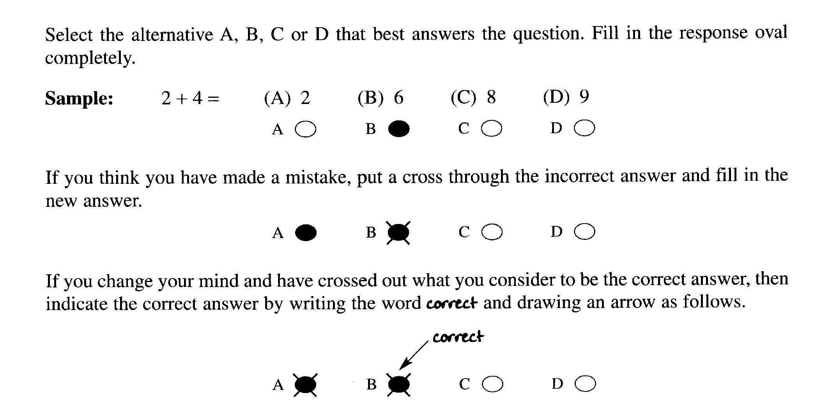

Indicate your answer on the answer grid on page 3

1. Fatty acids containing which range of number of carbon atoms are commonly used for soap-
making?

(A) from C₆ - C₁₀
(B) from C₁₀ - C₂₀
(C) from C₂₀ - C₃₀
(D) from C₃₀ – C₄₀

2. The production of sulfuric acid requires the oxidation of sulfur. What is the change in oxidation
number of sulfur in sulfur dioxide compared to that in sulfuric acid?

(A) 2 to 4
(B) 4 to 6
(C) 2 to 6
(D) 4 to 8

3. Identify the diagrammatic representation of the shapes and electrical charges of corresponding
surfactant molecules

(i) 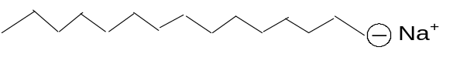

(ii) 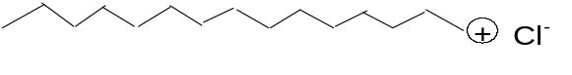

(iii) 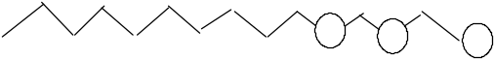

(iv) 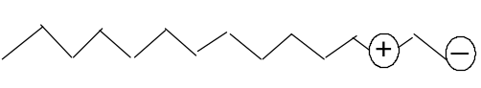

 | Anionic | Cationic | Non-ionic
(A) | (i) | (ii) | (iii)
(B) | (ii) | (i) | (iii)
(C) | (iv) | (ii) | (iii)
(D) | (v) | (i) | (iii)

4. 1.0 kg. of sodium hydrogen carbonate was heated and a complete reaction occurred

2NaHCO₃(s) → Na₂CO₃(s) + CO₂(g) + H₂O (g)

What volume of carbon dioxide gas would be produced at 100 kPa and 25ºC?

(A) 11.9 L
(B) 147.5 L
(C) 295 L
(D) 590.2 L

Section A Student Number………………

Multiple Choice Answer Grid

1. A O B  C O D O

2. A O B  C O D O

3. A  B O C O D O

4. A O B  C O D O

Section B: Short Answer Questions

Question 5 (6 marks) MARKS

Sulfuric acid is often described as the world’s most important industrial chemical because of
the great variety and importance of the uses to which it is put.

(a) Identify one important substance which requires sulfuric acid for its production. 1

sulfate of ammonia

(b) Using equations, only, outline the three main steps in the contact process. 3

S(l) + O₂(g) → SO₂(g)

2 SO₂(g) + O₂ 2 SO₃ (g)

SO₃(g) + H₂SO₄ (l) → H₂S₂O₇(l)

H₂S₂O₇(l) + H₂O (l) → 2 H₂SO₄ (l)

- Describe the result for a dehydration experiment using concentrated sulfuric acid and the
safe work practices that were employed. 2

The experiment was conducted by the teacher under the fume cupboard. The teacher
was wearing protective clothing, gloves and safety glasses. (1 mark)
When concentrated H₂SO₄ was added to crystals of copper (II) sulfate. pentahydrate in a test tube, the blue crystals turned to a white, powdery solid (1 mark)
Question 6 (4 marks) MARKS

The Solvay process has been in use since the 1860’s.

- What is the Solvay process used to manufacture? 1

sodium carbonate

- Identify one use for this substance? 1

manufacture of paper, glass and a water softener

- During this process ammonia is used and converted to ammonium chloride. Name the
substance that is mixed with ammonium chloride in order to recover the ammonia? 1

calcium hydroxide or slaked lime

- Write a balanced chemical equation to show the production of ammonia. 1

Ca(OH)₂ + 2 NH₄Cl → CaCl₂ + 2 NH₃ + 2 H₂O

Question 7 (6)

There are three electrolysis methods used to produce sodium hydroxide. Distinguish between the diaphragm process and the mercury process by identifying the anode and cathode materials,
describing the chemical reactions involved and comparing the purity of the products in
each process. 6

Criteria | Mark(s)
Chemical reactions for each process  Diaphragm  Mercury | 5  (2)  (3)
Purity of product | 1

Possible answer:

The diaphragm process uses a steel mesh for cathode and the mercury process uses a mercury cathode.
Both the mercury process and the diaphragm process make use of either a graphite or titanium coated
with titanium ruthenium oxide as anode. (no credit for this answer)
Reactions at each electrodes:
Mercury process:
Cathode: 2Na⁺(aq)+ 2 e-à 2Na(Hg)
2 Na(Hg) + 2 H₂O(l) à 2 NaOH(aq) + H₂(g)

Anode: 2 Cl⁻(aq) à Cl₂(g) + 2 e-

Diaphragm process:
Cathode: 2 H₂O (l) + 2 e- àH₂(g) + 2 OH-(aq)
Anode: 2 Cl⁻(aq) à Cl₂(g) + 2 e-

With the diaphragm process, the non-selective nature of the asbestos diaphragm results in a sodium hydroxide product which is highly contaminated with sodium chloride. Relatively purer sodium hydroxide solution is produced in the mercury process because the sodium hydroxide is generated in a separate compartment by reaction of the Na(Hg) with water.
Question 8 (4 marks)
Imagine you are an organic chemist and you are to design a new laundry detergent for washing oily and soiled clothes . Describe the structure of the detergent molecule you will synthesise and explain how it works.

Criteria | Marks
description of molecule | 2
description of how it works | 2
Possible answer:
Description of the structure of the molecule:
The surfactant molecule should consist of a straight hydrocarbon chain terminating with a negatively charged end which could be a sulphonic acid group. (an anionic surfactant). This is electrostatically bonded to a potassium or a sodium ion. . This part of the molecule is polar while the rest of the molecule is non- polar.
How the surfactant works:
Such a molecule having a polar end and a non-polar end will be capable of interacting with both water and the oily residues on the clothing. The polar end can interact with water through dipole-dipole interaction while the non-polar part can interact with the oil by dispersion forces. The surfactant then is a “bridge” between oil and water and hence enabling the oil to be washed off the clothing by the water.
Other suitable answers will also be considered.

END of TEST

